**Industrial Internship Report on**

**Password Manager**

**Prepared by**

**ARITRA DUTTA**

|  |
| --- |
| *Executive Summary* |
| This report provides details of the Industrial Internship provided by upskill Campus and The IoT Academy in collaboration with Industrial Partner UniConverge Technologies Pvt Ltd (UCT).  This internship was focused on a project/problem statement provided by UCT. We had to finish the project including the report in 6 weeks’ time.  My project was Password Manager using Python.  This internship gave me a very good opportunity to get exposure to Industrial problems and design/implement solution for that. It was an overall great experience to have this internship. |

**TABLE OF CONTENTS**

1 Preface 3

2 Introduction 5

2.1 About UniConverge Technologies Pvt Ltd 5

2.2 About upskill Campus 9

2.3 Objective 11

2.4 Reference 11

2.5 Glossary 11

3 Problem Statement 12

4 Existing and Proposed solution 13

5 Proposed Design/ Model 14

6 Performance Test 18

6.1 Test Plan/ Test Cases 18

6.2 Test Procedure 18

6.3 Performance Outcome 18

7 My learnings 20

8 Future work scope 21

# Preface

It has been a great experience working as a python intern for Upskill. This internship taught me a lot about how things work in a workplace, and also developed my skills as a whole. Throughout the six weeks, we have been provided with video lectures to learn more about the concepts of python. We have been giving quizzes as well to test our knowledge. The project that were allocated to us has been a great source of knowledge for us. Overall it was a great experience working as an intern here.

Internship is a very important part for our engineering career. Not only does this give a good impression to the hiring manager at the time of interview but also, gives us an opportunity to test out knowledge before going into the real workplace. Working as an intern is a wholesome experience since it gives knowledge regarding the work as well as a good place to test your skills.

I have worked on the project – Password Manager using Python. It is named as SecretKey. It allows the users to store their passwords for various accounts, generate strong passwords for them, if asked, and retrieve passwords when needed. The scope of this project involves implementing encryption algorithms to secure password storage, designing a user interface to input and retrieve passwords, and developing functions to generate strong passwords and store/ retrieve them from a database.

This was a great opportunity by USC/UCT. I came to know about so much while working here. Be it my own skills or the real world applications of various projects. It helped me strengthen my knowledge on python as well as I got to learn many new things. I am blessed to have an opportunity like this.

How Program was planned

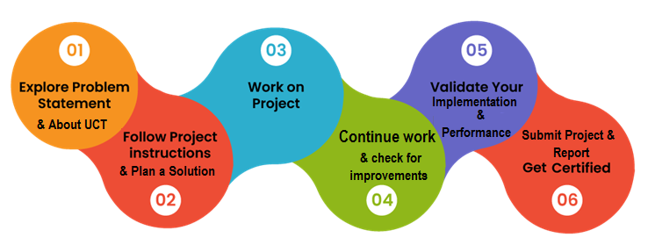

This internship has been a great learning opportunity for me. I have been learning new technologies like – Tkinter, sqlite3 etc. for this project. While working on this project I faced many difficulties and I managed to overcome them all. Overall this internship has been very helpful for me both academically as well as personally.

Thanks to all the Mentors of Upskill, who have helped you directly or indirectly.

To my juniors and peers, I would like to send this message that no matter what problem you face while working, don’t lose hope. Try to find out solutions since you will get to learn a lot from it. Doing a good internship always boosts your own skills and it gives a good impression about you to the hiring manager at the time of interview.

# Introduction

## About UniConverge Technologies Pvt Ltd

A company established in 2013 and working in Digital Transformation domain and providing Industrial solutions with prime focus on sustainability and RoI.

For developing its products and solutions it is leveraging various**Cutting Edge Technologies e.g. Internet of Things (IoT), Cyber Security, Cloud computing (AWS, Azure), Machine Learning, Communication Technologies (4G/5G/LoRaWAN), Java Full Stack, Python, Front end**etc.

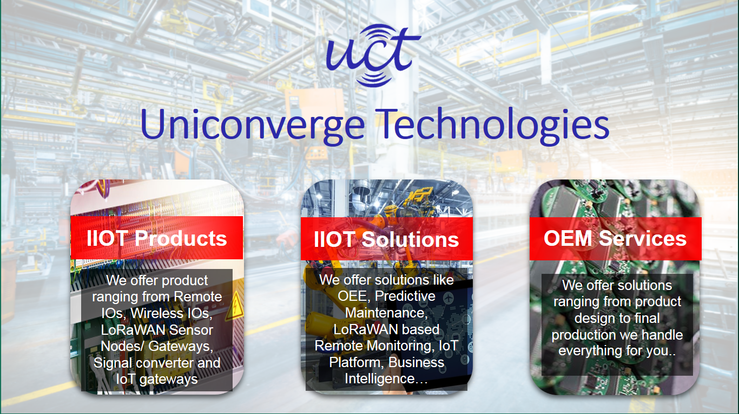

1. UCT IoT Platform **(****)**

**UCT Insight** is an IOT platform designed for quick deployment of IOT applications on the same time providing valuable “insight” for your process/business. It has been built in Java for backend and ReactJS for Front end. It has support for MySQL and various NoSql Databases.

* It enables device connectivity via industry standard IoT protocols - MQTT, CoAP, HTTP, Modbus TCP, OPC UA
* It supports both cloud and on-premises deployments.

It has features to  
• Build Your own dashboard  
• Analytics and Reporting  
• Alert and Notification  
• Integration with third party application(Power BI, SAP, ERP)  
• Rule Engine

 

1. **Smart Factory Platform (****)**

Factory watch is a platform for smart factory needs.

It provides Users/ Factory

* with a scalable solution for their Production and asset monitoring
* OEE and predictive maintenance solution scaling up to digital twin for your assets.
* to unleased the true potential of the data that their machines are generating and helps to identify the KPIs and also improve them.
* A modular architecture that allows users to choose the service that they what to start and then can scale to more complex solutions as per their demands.

Its unique SaaS model helps users to save time, cost and money.

 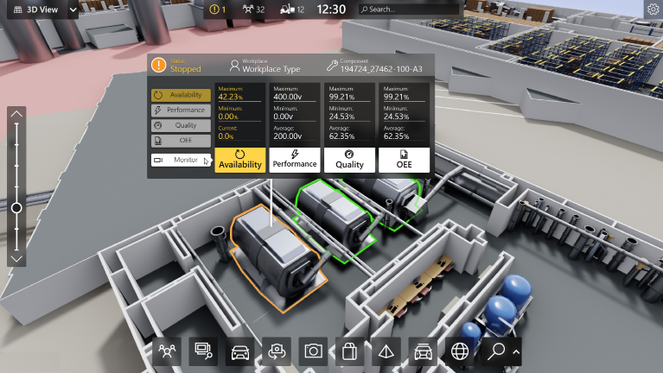

1. 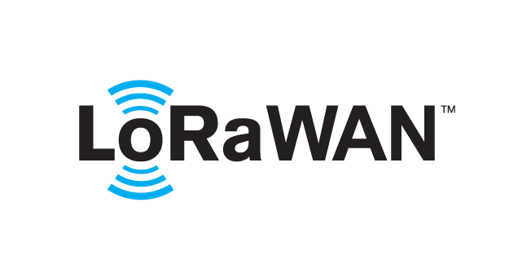 based Solution

UCT is one of the early adopters of LoRAWAN teschnology and providing solution in Agritech, Smart cities, Industrial Monitoring, Smart Street Light, Smart Water/ Gas/ Electricity metering solutions etc.

1. Predictive Maintenance

UCT is providing Industrial Machine health monitoring and Predictive maintenance solution leveraging Embedded system, Industrial IoT and Machine Learning Technologies by finding Remaining useful life time of various Machines used in production process.



## About upskill Campus (USC)

upskill Campus along with The IoT Academy and in association with Uniconverge technologies has facilitated the smooth execution of the complete internship process.

USC is a career development platform that delivers **personalized executive coaching** in a more affordable, scalable and measurable way.



Seeing need of upskilling in self paced manner along-with additional support services e.g. Internship, projects, interaction with Industry experts, Career growth Services

<https://www.upskillcampus.com/>

upSkill Campus aiming to upskill 1 million learners in next 5 year



Seeing need of upskilling in self paced manner along-with additional support services e.g. Internship, projects, interaction with Industry experts, Career growth Services

<https://www.upskillcampus.com/>

upSkill Campus aiming to upskill 1 million learners in next 5 year

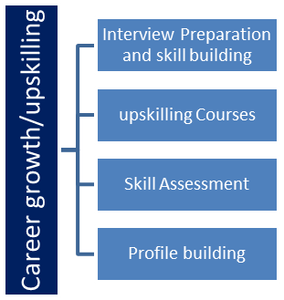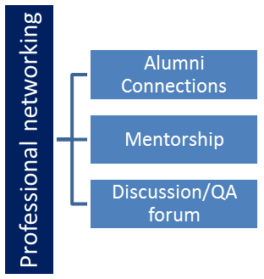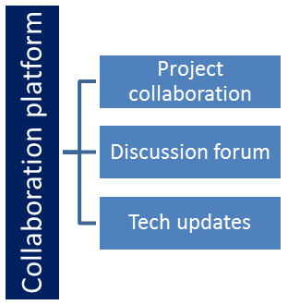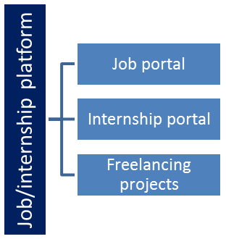

## The IoT Academy

The IoT academy is EdTech Division of UCT that is running long executive certification programs in collaboration with EICT Academy, IITK, IITR and IITG in multiple domains.

## Objectives of this Internship program

The objective for this internship program was to

 ☛ get practical experience of working in the industry.

 ☛ to solve real world problems.

 ☛ to have improved job prospects.

 ☛ to have Improved understanding of our field and its applications.

 ☛ to have Personal growth like better communication and problem solving.

## Reference

[1] W3Schools - <https://www.w3schools.com>

[2] Stack Overflow - <https://stackoverflow.com>

[3] Geeks for Geeks - <https://practice.geeksforgeeks.org>

## Glossary

|  |  |
| --- | --- |
| Terms | Acronym |
|  |  |
|  |  |
|  |  |
|  |  |

1. **Problem Statement**

Create a Password Manager Application that allows the users to securely store and manage their passwords. It allows the users to store their passwords for various accounts, generate strong passwords for them, if asked, and retrieve passwords when needed. The scope of this project involves implementing encryption algorithms to secure password storage, designing a user interface to input and retrieve passwords, and developing functions to generate strong passwords and store/ retrieve them from a database.

# Existing and Proposed solution

Upon researching most of the password managers that are prevalent in the current market are present in the form of a website. Applications are also present but their numbers are seemingly less. Also they just save the passwords and they do not provide any solution to generate random strong passwords.

As the problem statement suggests, the main requirements of the application should be to store and retrieve the passwords. Besides it should also be able to generate random strong password. And at the end the passwords and other data should be completely encrypted such that they are secured. This project of mine provides all these essential features in a single platform. The user will login using a master password and will be able to add his own or strong generated passwords along with the website name and user name of the website. He will also be able to change the user name and password as well as delete them anytime he wants. The passwords and other important details are completely encrypted and stored in the database.

## Code submission (Github link) : <https://github.com/aritra-dutta11/SecretKey/tree/master>

## Report submission (Github link) : [Project Report Here.](https://github.com/aritra-dutta11/SecretKey/blob/master/Aritra%20Dutta_Upskill_Final%20Report.docx)

# Proposed Design/ Model

The Application that I developed is a pop up application, built with Tkinter. If the person has no entry in the database, he will be asked to set a master key, and a security answer. The master key is changeable but the security answer is un-changeable. After it is done, a login screen will pop up and will ask for the master password. If the password is correct, a password vault will open where all the passwords will be displayed.

The vault has an option to add a password. On clicking it, a new window will pop up asking for the website name, user name and the password. It will also has a ‘Generate Password’ button that will generate a strong password for the user and will copy in the user’s clipboard. The add button will add it to the database. All these details are encrypted with the security answer of the user. The password vault will display the details along with two buttons – ‘Update’ and ‘Delete’. The update button will pop up a same screen as the ‘Add’ button, just the website name will be unchangeable, and other parts are same. The ‘Delete’ button will simply delete it from the database.

In case the user wants to reset the master key, he has to enter the security answer, and he will be redirected to a new screen for choosing the new password. The master password, security answer are all encrypted.

**Register Screen**

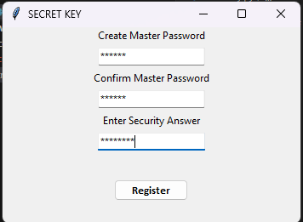

**Login Screen**

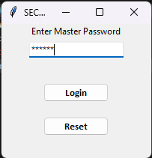

**Vault**

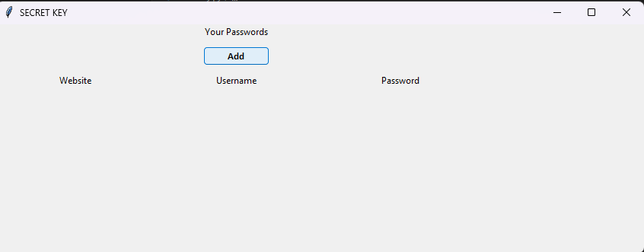

**Adding a New Password**

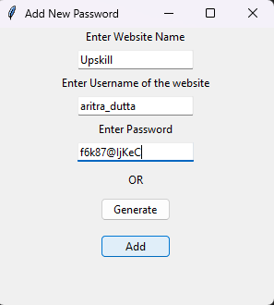

**Vault with Passwords**

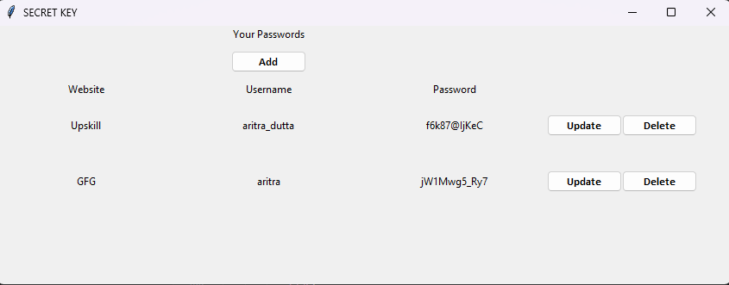

**Updating Master Password**

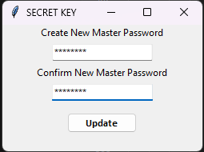

# Performance Test

## Test Plan/ Test Cases

The plan regarding the performance test was to encrypt the details that are being entered by the user. This is so if the database gets leaked, the details remain hidden from the attacker. The website name, master password, user-name and password are all to be encrypted in order to save them from cyber-attacks.

## Test Procedure

The encryption is done with the help of ‘cryptography’ package of python. The hashing algorithm used is SHA256. Hashing is very essential since a hashed text or data cannot be changed back to the original form. The user inputs a security answer while registering. This security answer is used to make the encryption key. The PBKDF2HMAC is used to generate the key. The code is given below.

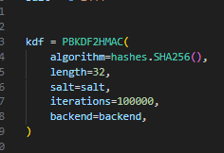

The encryption key is used to encrypt the data while entering it into the database and decrypting it while displaying in the main vault screen. The details are first encoded then encrypted using the encryption key.

## Performance Outcome

The data is perfectly encrypted and stored in the database. The image below shows the columns of the database with the encrypted data.

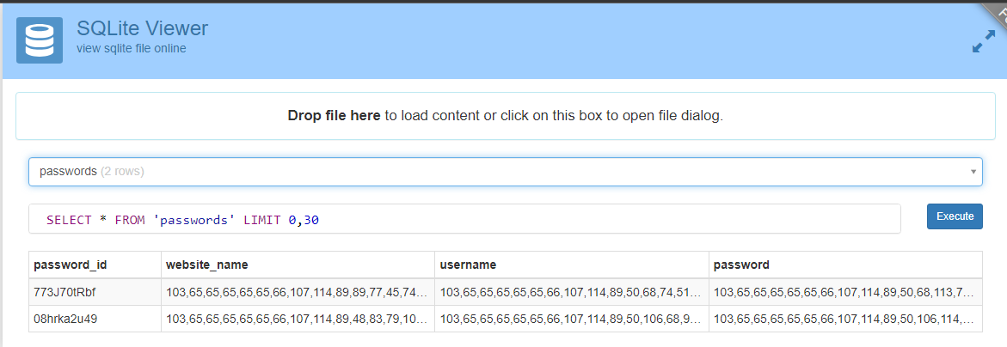

Thus, all the data is successfully encrypted.

# My learnings

This project helped me a lot to master python and its libraries. I was just a beginner in python when I started this internship. These are some of the things I learned through this internship.

* The entire Tkinter library was new for me. But upon researching for this project, I managed to gain a lot of knowledge about it.
* This project helped me a lot with sqlite3. I managed to perform CRUD applications with it and now I can perform them better than ever.
* I had no knowledge about cryptography, but while doing this project I managed to gain basic knowledge about it and about encryption/decryption etc.
* Last but not the least, this project helped me a lot with the basics for python, like functions, arrays etc.

# Future work scope

This project can be improvised in the future to make it more effective as a password manager. One such is that – a timer may be implemented with it such that it notifies the user to change his passwords after a given period of time (say 30 days). This ensures security for the user as well. Also the UI can be changed a bit to make it more attractive.